Fusion of Modernity and Tradition: Architectural Design

for Banda Aceh's Culinary Center

Rahmi Ananda¹, Aulina Adamy¹, T. Eka Panny Hadinata^{1*}

¹Faculty of Engineering, University of Muhammadiyah Aceh, Indonesia

*Corresponding Author: teuku.eka@unmuha.ac.id

Abstract. Banda Aceh currently lacks a dedicated space that both celebrates and educates the public about Indonesia’s rich culinary heritage. The proposed Nusantara Culinary Center aims to fill this gap by integrating recreation, education, and culinary experiences, with supportive facilities that enhance visitor engagement. Beyond serving as a cultural and economic driver, the center is envisioned as a regional icon, showcasing the diversity of Indonesian cuisine. This project leverages modern technological advancements to create a contemporary architectural design that harmonizes history and technology. By adopting a dynamic, non-linear massing and integrating basic geometric forms, the design seeks to produce an expressive and vibrant environment. Emphasizing openness and connectivity, both the interior and exterior spaces foster an interactive relationship between visitors and the surrounding environment, making outdoor areas central to the design. Located in the Ulee Lheue area of Banda Aceh, the Nusantara Culinary Center will include a range of facilities such as restaurants, cafes, and food stalls, along with support services like management areas, parking, and public amenities. The project’s design aims to not only create a culinary destination but also promote sustainable urban development by supporting local economic activities.

Keywords: contemporary architecture, culinary center, Banda Aceh, technological integration

Introduction
According to Undang-Undang Republik Indonesia No.10 Year 2009 on tourism, the tourism sector encompasses a variety of travel activities supported by facilities and services provided by society, businesses, and government entities, including culinary tourism. The culinary arts represent a significant potential for attracting tourists and play a crucial role in Indonesia's tourism industry, with 60% of tourism driven by the creative industries, one of which is culinary tourism (Ministry of Tourism, 2016).
Aceh, a region known for its cultural richness, holds a distinct place in Indonesia’s culinary landscape, particularly for its use of spices. Like many regions in Indonesia, Aceh boasts a variety of unique dishes that have the potential to attract both local and international tourists (Directorate General of Culture Aceh, 2023). The Mayor of Banda Aceh, Aminullah Usman, has emphasized the importance of developing a culinary tourism center as part of the government's efforts to enhance tourism and create new economic opportunities in Banda Aceh.
In recent years, Aceh’s culinary scene has gained momentum, attracting interest from locals and tourists alike. The rise of food trucks, street food vendors, and other culinary outlets in Banda Aceh, particularly in the Ulee Lheu area, has created a vibrant culinary hub. However, most of these establishments are privately owned, and there remains a shortage of recreational and educational facilities related to culinary arts. While culinary festivals are held annually at various locations such as Blang Padang Field, Convention Hall, and Taman Bustanussalatin, these events are typically temporary, limiting the experience for visitors (Ministry of Tourism and Creative Economy, 2023).
Though the culinary offerings in Banda Aceh are diverse, featuring dishes from across the region and beyond, they have not yet fully captured the culinary diversity of the Indonesian archipelago. This underscores the need for a permanent Nusantara Culinary Center in Banda Aceh, which would serve multiple functions—commercial, recreational, and educational. Such a center would not only strengthen the local economy but also serve as a regional icon, celebrating the rich culinary traditions of Indonesia's many islands.
The concept for this Nusantara Culinary Center integrates contemporary architectural principles, blending modern advancements with cultural heritage. By incorporating technological innovations and diverse architectural styles, the center will provide a unique, modern environment where visitors can experience the rich flavors of the archipelago. This fusion of traditional and modern elements is expected to attract a wide range of visitors, contributing to both the cultural and economic vitality of Banda Aceh. The Nusantara Culinary Center in Banda Aceh is conceptualized as a key culinary attraction based on elements outlined by the International Culinary Tourism Association (ICTA). As a culinary destination, the center will host activities such as food festivals, exhibitions, and other events that highlight the rich diversity of Indonesian cuisine. The following sections outline its classification based on type, venue, and management system.
The Nusantara Culinary Center in Banda Aceh is classified as a Food Market, a venue where visitors can enjoy a variety of food and beverages while socializing with friends, family, or colleagues (Mufidah, 2012). In addition, the center functions as a Restaurant, which is defined as a commercially organized establishment providing quality food and beverage services for dining or drinking purposes (WA, 2005). The center is further classified as a Café and Restaurant, offering a combination of informal and formal dining options. This dual classification allows for a flexible culinary experience, catering to a wide range of preferences and occasions. The Nusantara Culinary Center adopts a Specialties Restaurant management system, as outlined by (Soekresno, 2000). A Specialties Restaurant is characterized by its commercial and professional management of traditional cuisine, focusing on unique presentation styles that represent specific cultural or national culinary traditions. This system ensures that the center maintains a high standard of service while offering authentic culinary experiences.

Design Theme
Contemporary Architecture is characterized by its grounding in technological advancements and its openness to creative expression. It is a fluid style that incorporates elements from various architectural styles without imposing rigid boundaries.
Classification of themes according to architectural critic (Jencks, 1981):
- Ideology: Refers to the conceptual framework that guides the design, offering purpose and direction for a systematic approach to contemporary architecture.
- Style: Encompasses the various forms and methods that define contemporary architecture, focusing on the unique visual and structural aspects of the design.
- Design Idea: The foundational concept from which architectural works emerge, acting as the starting point for the design process in contemporary architecture.

Principles of Contemporary Architecture
The design of contemporary architecture is guided by several key principles (Schirmbeck, 1987): (a) Solid building structures; (b) Expressive and dynamic mass compositions; (c) Spatial concepts that promote openness; (d) Integration of indoor spaces with the surrounding environment; (e) Transparent facades; and (f) Exploration of structured landscape elements.

Application of Theme in Buildings
- Concept and Ideology
The design of the Nusantara Culinary Center reflects contemporary architecture by employing semiotic forms that are easily understood. Expressive and dynamic design elements are used to symbolize the historical and technological significance of culinary arts. The transformation of forms, gradually increasing in size, represents progress and change while maintaining their original essence.
- Style and Aesthetic Expression
The building’s style integrates the themes of Variable Space with Surprise and Pro-Historical Reference. This is evident in both the interior and exterior designs, which evoke a sense of nostalgia through materials like bamboo and wood, creating a warm and familiar atmosphere reminiscent of the past. Traditional Nusantara motifs, such as batik carvings, are incorporated as decorative elements to honor Indonesia's cultural heritage. Despite these historical references, the building uses modern materials and technologies. Transparent facades and strategic openings emphasize openness and fluidity between indoor and outdoor spaces, enhanced by the inclusion of an inner courtyard that merges the exterior environment with the building.
- Design Idea and Hi-Tech Integration
The design of the Nusantara Culinary Center adopts a Hi-Tech approach. The transparent facade allows ample natural light into the building, creating an inviting and open ambiance while showcasing the building’s technological sophistication. The use of smart materials, such as reflective glass to reduce heat and light, aligns with the Hi-Tech concept. Additionally, renewable materials are incorporated into the facade to manage light diffusion, further emphasizing the center's modern, sustainable design.

- Location Description
The Nusantara Culinary Center is situated on Jalan Pelabuhan Lama in the Ulee Lheue area of Banda Aceh. The site spans 36,229 m² (3.6 hectares), offering ample space for the development of a multi-functional culinary destination. This strategic location, near both urban and coastal areas, positions the center as a key culinary hub within Banda Aceh, accessible to both locals and tourists.

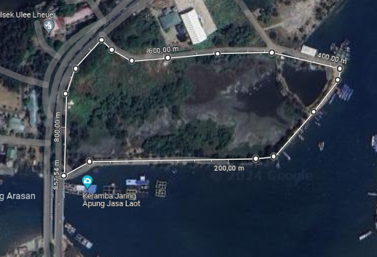
Figure 1. Site’s map

Design Analysis
User Analysis
  - Visitors
The Nusantara Culinary Center in Banda Aceh is projected to accommodate an average of 1,219 visitors per day over the next 10 years, reflecting its potential as a major culinary attraction in the region.
- Tenants
The center will require a variety of traders and employees to support its commercial activities. The commercial facilities available for rent include 5 restaurants, each representing a different culinary tradition from the 5 major islands of the Indonesian archipelago, 1 café, 75 food stalls, and 12 food trucks located outside the building.
- Management
The management structure for the center can either be government-appointed personnel or private operators. A total of 102 management staff will be needed to oversee the smooth operation of the Nusantara Culinary Center.

Activity and Space Requirement Analysis
The space requirements at the Nusantara Culinary Center have been analyzed based on activity zoning, with the following zones identified:
  - Public Zone: Includes areas accessible to all visitors, such as parking, plaza, hall, reception, and security post;
  - Semi-Public Zone: Encompasses dining and recreational spaces, including restaurants, café, food stalls, food trucks, display/exhibition areas, indoor and outdoor dining areas, private dining areas, flower gardens, playgrounds, photo spots, and a fish pond/fountain;
  - Private Zone: Reserved for administrative functions, featuring spaces such as the manager’s office, secretary’s office, administrative division office, marketing division office, finance division office, and meeting rooms;
  - Service Zone: Includes essential support facilities, such as the AHU room, generator room, pump room, CCTV room, cleaning room, lactation room, restrooms, prayer room, and ATMs.

Spatial Organization
  - Macro Spatial Organization

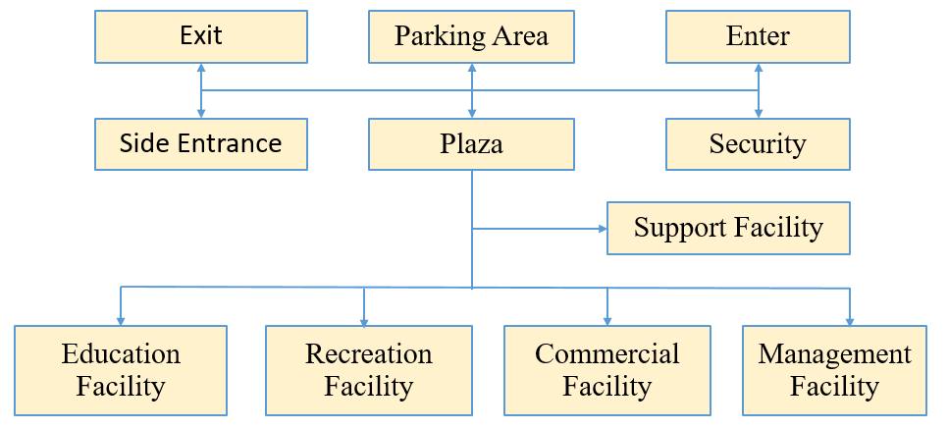
Figure 2. Macro spatial organization

  - Micro Spatial Organization

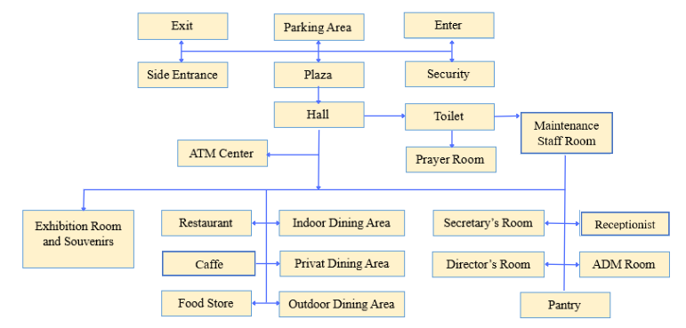Figure 3. Micro spatial organization (Visitors)

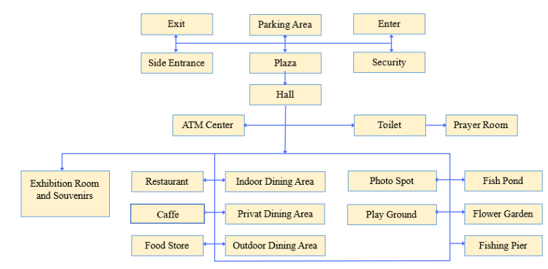
Figure 4. Micro spatial organisation (Management)

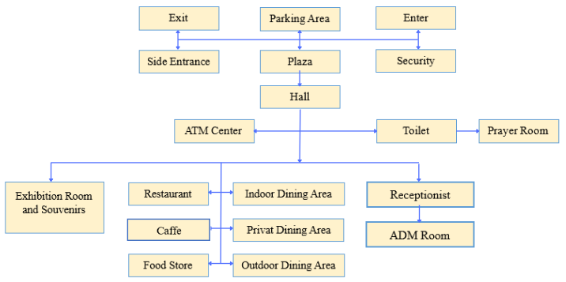
Figure 5. Micro spatial organization (Tenants)
Spatial Dimensions

Table 1. Recapitulation of spatial requirements
Facility | Floor Area
Main facility | 8.248,96 m²
Management facility | 948,00 m²
Support facility | 1.795,36 m²
Total | 10.992,32 m²

Table 2. Recapitulation of total parking area requirements
Parking Facility | Area
Visitors parking four wheeled | 1.150 m²
Visitors parking two wheeled | 488 m²
Management parking four wheeled | 500 m²
Visitors parking two wheeled | 122 m²
Bus Parking | 280 m²
Total | 2.540 m²
Circulation 60% | 1.524 m²
Grand Total | 4.064 m²

Site Analysis
The site analysis for the Nusantara Culinary Center includes assessments of climate, noise, views, circulation, and accessibility. The findings are as follows:
- Climate Analysis
The climate analysis suggests several design strategies to enhance comfort and energy efficiency. The building is oriented centrally on the site in an elongated layout to minimize direct sunlight exposure. Vegetation is used as natural shading for outdoor areas, while angled building forms and secondary skins mitigate the impact of strong winds. Drainage channels and permeable paving are incorporated to reduce rainwater accumulation.
- Circulation and Accessibility Analysis
The site is accessible from Jalan Pelabuhan Lama Ulee Lheue, a major arterial road. Separate entry and exit points are recommended to prevent internal traffic congestion and ensure smooth circulation within the site.
- Noise Analysis
Although the culinary center will naturally generate noise due to its function, noise is not a significant concern. However, areas requiring a quieter atmosphere should be placed away from high-activity zones to maintain acoustic comfort.
- View Analysis
The site's views toward the main road and river present an opportunity to enhance the building's visual appeal. Strategic openings are designed to capture these views, drawing visitors' attention and maximizing the aesthetic potential of the site.
- Buildings Analysis
The building analysis covers circulation patterns, structure, materials, and utilities:
- Circulation Patterns: The building employs a combination of linear, networked, and radial circulation systems, guiding movement efficiently throughout the culinary center.
- Structural Systems: The foundation employs a footing and well foundation to support the building's load. A rigid frame system is used for the superstructure to handle both vertical and horizontal loads. The roofing system consists of a concrete slab and space frame to provide structural integrity.
- Materials: Flooring materials include parquet for exhibition areas, granite for interior spaces, and paving blocks for outdoor areas. The walls are constructed using lightweight concrete blocks (habel) and laminated glass for transparency and aesthetic appeal.
- Utility Systems: The utility systems cover essential building functions, including HVAC, lighting, fire safety, sanitation, electrical systems, vertical transportation, and waste management—each critical for the operation of this commercial facility.

- Design Concept
This section outlines the key design principles applied to the Nusantara Culinary Center, focusing on theme implementation, site concept, and building features.

Theme Application Concept
  - Ideology Classification
- The design follows the Semiotic-Form ideology, where the building's appearance and style are easy to interpret. This concept uses contrasting sizes in the massing composition, symbolizing transformation. The progression from smaller to larger forms conveys movement and applies contemporary principles of expressive massing, highlighting the historical significance of culinary arts and technological development.
- Style Classification
- The architectural style integrates Variable Space with Surprise and Pro-Historical Reference. This is reflected in the building’s interior design, which evokes a nostalgic atmosphere through materials reminiscent of bamboo, wood, and batik—giving a warm impression. These traditional elements are combined with modern materials to enhance the contemporary feel. The open-space concept is applied with glass walls between rooms, creating a sense of openness. Harmonization with the outdoors is achieved through an internal courtyard, bringing an exterior ambiance into the building
- Design Idea Classification
- The design follows a Hi-Tech concept, featuring a modern aesthetic through dominant structural elements and the use of contemporary materials like glass, concrete, and steel. The facade incorporates Aluminium Composite Panels (ACP) with intricate cuttings symbolizing opposition in size, reinforcing the idea of change.

Site Concept
  - Zoning
The site is divided into four zones: public, semi-public, private, and service areas, each supporting specific activities and user needs.
- Site Circulation
Two circulation systems are emphasized: vehicle circulation around the building for easy access and pedestrian pathways to ensure smooth visitor movement across different zones.
- Parking System
The proposed parking system includes angled parking for four-wheel vehicles at a 60° incline, as well as designated parking for two-wheel vehicles.
Building Concept
  - Circulation
The building incorporates a mix of linear, network, and radial circulation systems, allowing users to navigate freely. The open-space layout fosters a sense of comfort and spaciousness.
- Module and Grid
The design utilizes a 10-meter grid and diagonal pattern, accommodating the structural framework while maintaining flexibility in spatial organization.
- Structural System
The foundation system consists of footings and wells, with a steel middle structure and a roof system featuring a concrete slab and space frame for stability and durability.
- Materials
- Walls: Lightweight concrete blocks, laminated glass, and composite membranes.
- Frames: Aluminium is used for door and window frames.
- Roof: Concrete slabs and laminated glass skylights.
- Ceiling: GRC panels.
- Flooring: Parquet in exhibition areas, granite indoors, and paving blocks outdoors.
e. Utilities
- Ventilation: Both natural ventilation (leveraging wind) and mechanical ventilation (air conditioning) are used.


Figure 6. Mechanical ventilation system

- Lighting: The design incorporates natural lighting from sunlight, supplemented by artificial lighting from electrical sources.

- Fire Safety: A comprehensive fire prevention and response system.

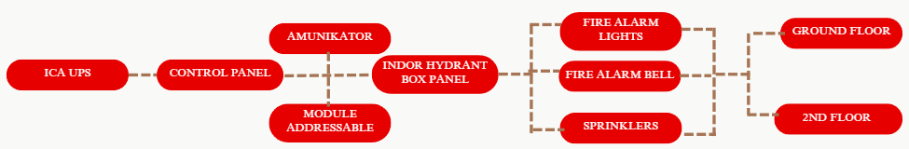
Figure 7. Fire safety system

- Sanitation: Two water systems—clean water and wastewater, with further division of wastewater into grey water and black water.

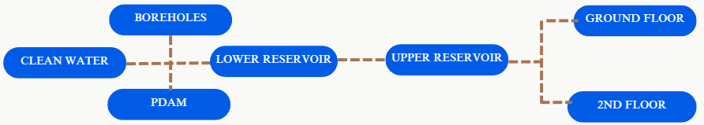
Figure 8. Clean water system

Figure 9. Grey water system

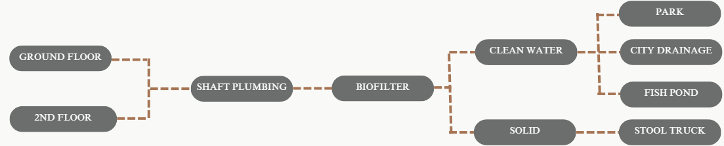
Figure 10. Black water system

- Electrical: An electrical system supporting the entire building's needs.
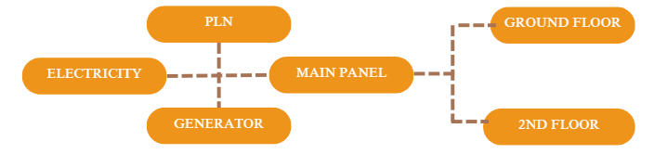
Figure 11. Electrical system

- Waste Management: A waste management system that complies with commercial building requirements.

Figure 12. Food waste management system


Figure 13. General waste system

- Vertical Transportation: Stairs and ramps are used to facilitate vertical movement between floors.

Form Concept
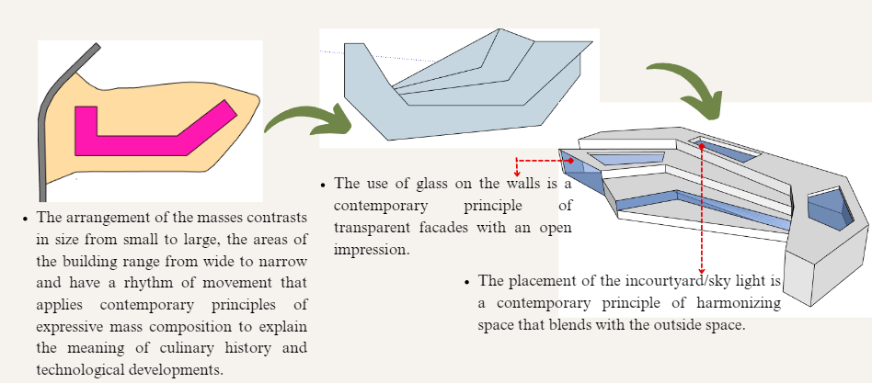
Figure 14. Form transformation
- Design Result
Layout Plan
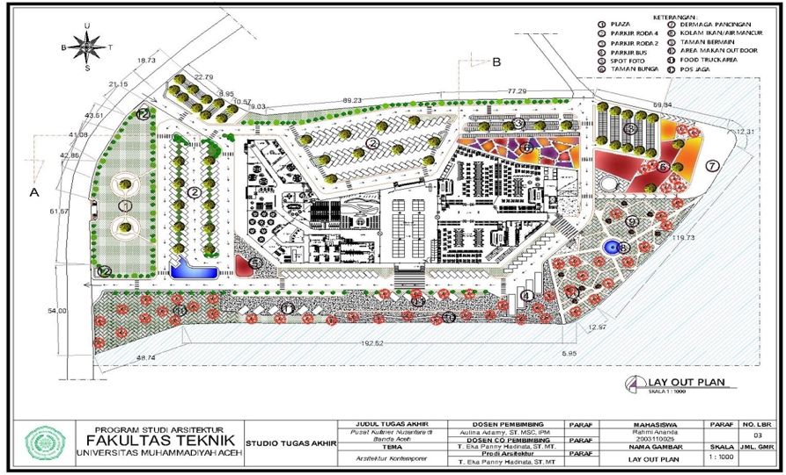
Figure 15. Layout plan

Floor Plans
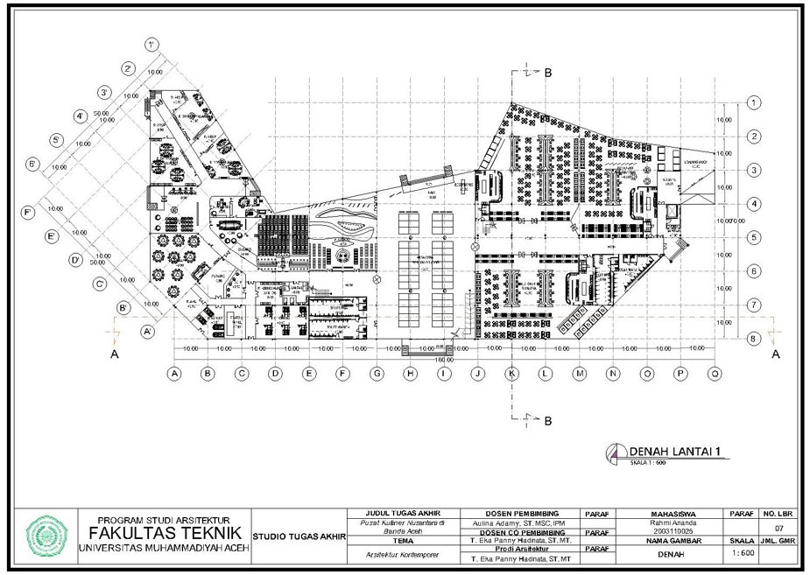
Figure 16. Floor plan for first floor

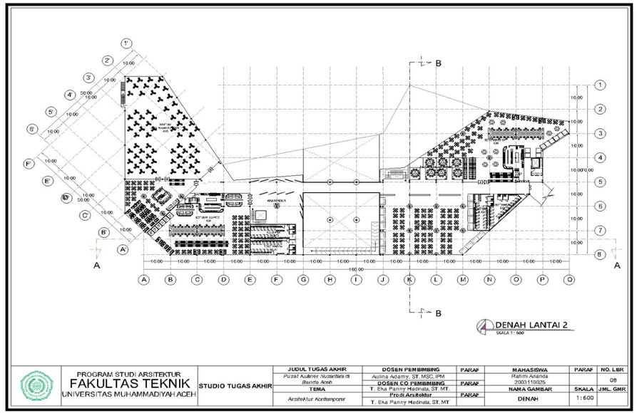
Figure 17. Floor plan for second floor
Elevations
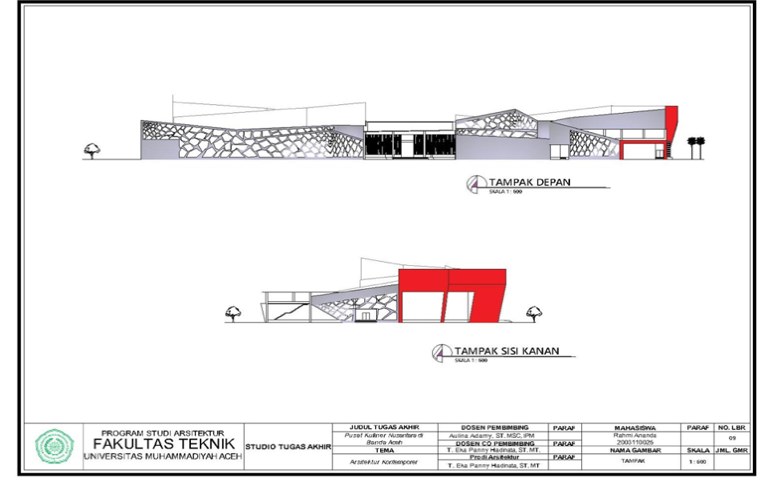
Figure 18. Front and right elevations

Perspective Three Dimensional Views
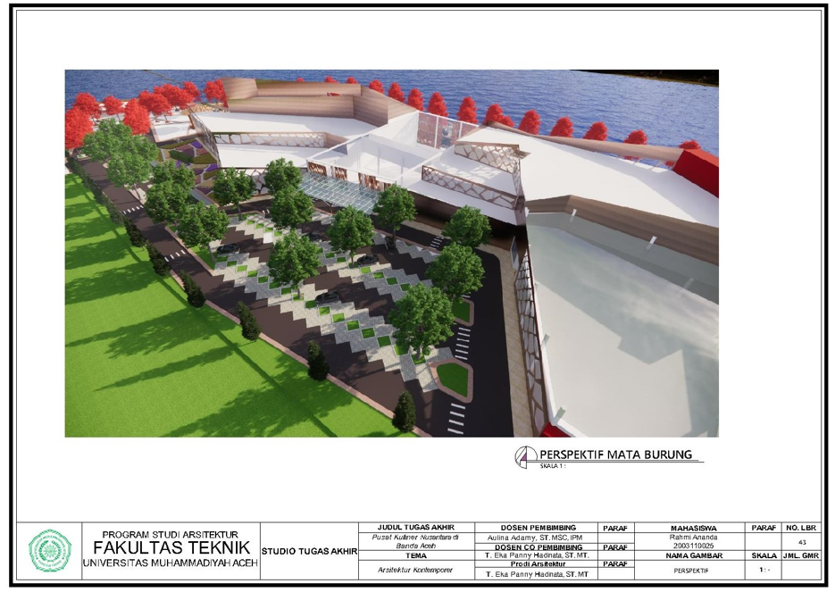
Figure 19. Bird’s eye view

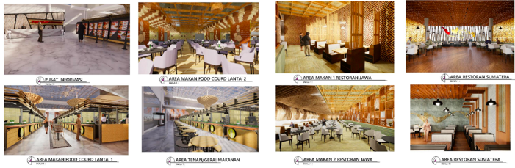
Figure 20. Interiors

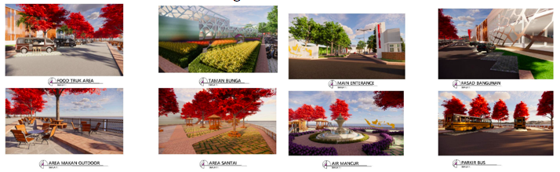
Figure 21. Exteriors

- References
Jencks, C. (1981). The Story of Post-Modernism. United States: John Wiley & Sons (UK).
Neufert, E. (2000). Neufert Achitects’ Data – Third Edition. Australia: Blackwell.
Neufert, E. (2001). Architects' Data- Second Edition. Australia: Balackwell.
Hilberseimer, L. (1964). Contemporary architecture: Its roots and trend. Chicago: Paul Theobald and Company
Marlina, E. (2008). Panduan Perancangan Bangunan Komersial. Yogyakarta: Andi Offset.
Schirmbeck, E. (1987). Idea, Form, and Architecture : Design Principles in Contemporary Architecture. New York: Van Nostrand Reinhold Company.
WA, M. (2005). Restoran dan Segala Permasalahannya. Yogyakarta: Andi Publhisher.
Soekresno. (2000). Manajemen Food and Beverage Service Hotel. Jakarta: Gramedia Pustaka Utama.
Agung Ardiansyah, D. W. (2021). Perancangan Pusat Wisata Kuliner Nusantara di Pantai Suradadi Dengan Konsep Arsitektur Neo-Vernakular. Journal of Architecture and Urbanism, 15:1 10-19.
Mufidah, N. (2012). Consumption Patterns of Urban Society (Descriptive Study of Foodcourt Utilization by Families). BioKultur, 1:2 157-178.
Qanun Kota Banda Aceh Nomor 4 Tahun 2009, tentang Rencana Tata Ruang Wilayah Kota Banda Aceh Tahun 2009-2029.
Undang-Undang (UU) Nomor 10 Tahun 2009 tentang Kepariwisataan.

